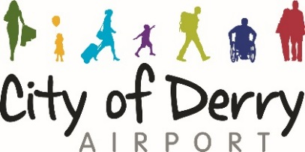

Quotation for the Supply of Mobile Phones for City of Derry Airport 2017

Company Name

Mobile Network Provider

CoDA Requirements: | Monthly Cost
7 x Iphone 6s
- Unlimited calls and text
- 1 GB of data
13 basic windows smart phones
- 500 mins
- Unlimited text
- 500 MB of data
Standard cost of calls to mobiles on same network
Standard dost of calls to mobiles on other network
Standard cost of calls to UK landline

Standard cost of International Calls

EU roaming charges

Itemised billing (cost per user)

Duration of Contract

Duration of warranty

Maintenance available

Additional charges / info

Total Monthly Cost:

Signed: _________________________ Date

