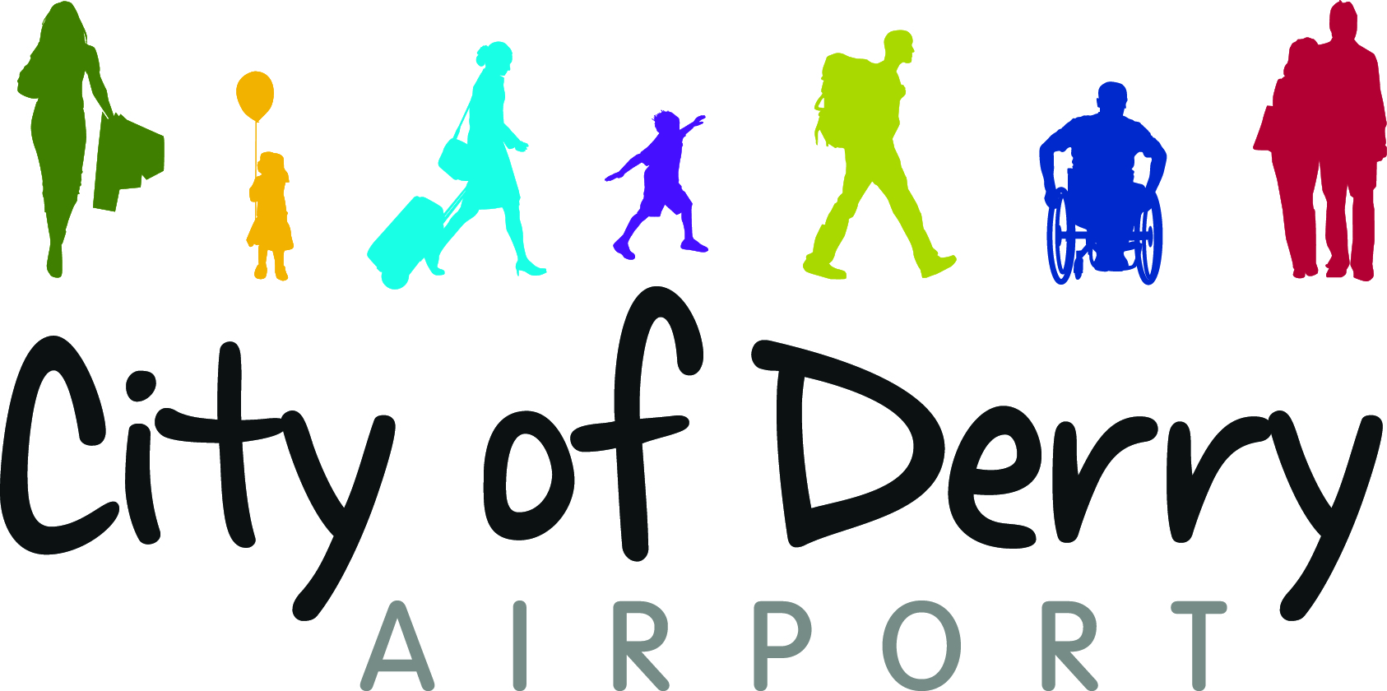

JOB DESCRIPTION

Job Title: Electrician
Department: Engineering
Salary: £21,000 per annum (pro-rata for temporary contract)

Job Summary:
The Electrician is Accountable to the AGL Electrician, for the day to day functioning of the Electrical section .
To provide efficient and effective maintenance of the equipment stated below in accordance with regulations specified by International standards, the Civil Aviation Authority and The City of Derry Airport procedures and policies.
Primary Responsibilities and Duties include:
The responsibilities of the Electrician include the following;
- Assist the AGL Electrician in completing all electrical tasks
- Assist with the approved maintenance regime and all Airport Electrical facilities and equipment.
- Ensure that the Electrical department complies with local and current Health & Safety at Work Regulations.
- Ensure test equipment is calibrated as required
- Annual checks on Equipment age viability and life cycle.
- Complete where appropriate control of contractor’s documentation.
- Providing assistance and support to the Ops Department during the annual Aerodrome Audits.
- Liaise with the Engineering Manager on:
- CAA annual audit reports
- Safeguarding matters
- Major equipment failures
- All matters of general uncertainty
- Ensuring compliance with all building regulations in relation to electrical installations

To ensure that the scheduled servicing and preventative and corrective maintenance of the following systems are carried out to the standards set out in CAP168, ICAO, and IEE regulations.

Building electrical installations, Baggage systems, minor maintenance on Air-conditioning equipment, heating/ ventilation plant, Lighting and Generators,
To exhibit good housekeeping at equipment sites, workshops, equipment rooms and stores.
Assist contractors during installation or repair of new or existing equipment.
To carry out control and replenishment of stock and equipment stores.
To keep abreast of technological advances relevant to the post and undertake training when required.
The accurate maintenance of all log books records, maintenance documentation and document control in accordance with SRG guidelines and the Airport SMS.
Assistance with equipment safety cases.
Carry out PAT Testing on all Airport Appliances.

In the execution of his duties the Electrician will consult the AGL Electrician on the following occasions;
- Any operational matters concerning the management of facilities electrical systems.
- Forward operational planning and major equipment purchases.
- Preparation of forward planning to include all Facility Electrical requirements
- Change management or change of procedure requirements.

All Other Duties:
This job description is only a summary of the range of the duties and responsibilities of the post. There may be additional duties and responsibilities, which will be commensurate with grade of the post that the post holder may be expected to undertake if so required and with appropriate training. Importantly they will be part of an integrated Engineering team and as such will be expected to assist other Engineers involved with Motor Transport, Building Maintenance and Air Traffic Engineering on a priority basis.

